Muhammad Fakhri Aiman Amrenorman
mba6052@psu.edu
Sample run 1: User generates a food order and deletes an item on the menu.

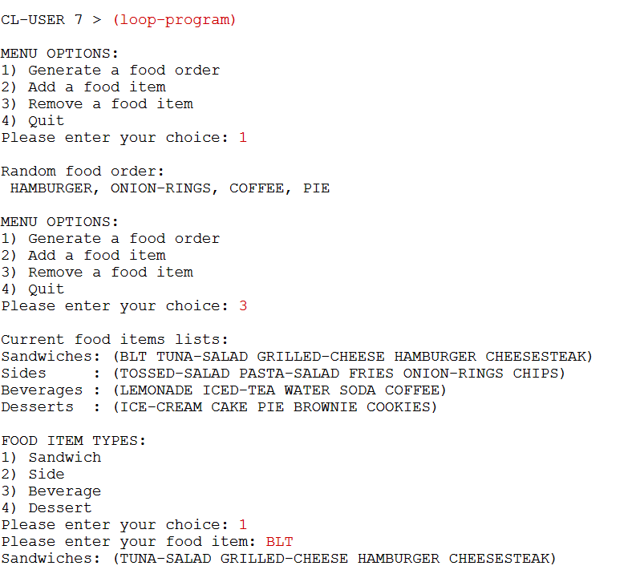
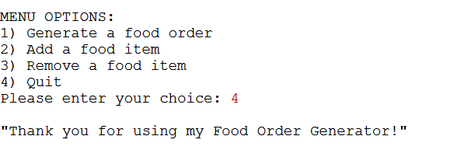

Sample run 2: User tries to input a wrong number and add an item

